JUNETEENTH

FACTS

**June 19, 1865**

News finally made it to Galveston, Texas announcing the end of slavery in the United States.

Two years earlier, January 1863 President Abraham Lincoln signed the Emancipation Proclamation which declared slaves in the Confederate States to be free.

**January 1,** **1980**

Juneteenth became a state holiday in Texas.

**June 17, 2021**

The U.S Senate unanimously approved the Bill to make Juneteenth a legal public holiday.

**June 19, 2021**

President Joe Biden signed legislation to make Juneteenth a federal holiday.

**The Juneteenth Flag**



The Juneteenth Flag was created by Ben Haith, the founder of the National Juneteenth Celebration Foundation.

A single White Star in the center represents Texas, the Lone Star State where Juneteenth was first celebrated;

The Burst, the outline surrounding the star, represents freedom for all black people in the 50 states;

The Arc represents new opportunities and hope for the future.

Red, white and blue share the same colors of the American Flag.

**Juneteenth**

Also known as: Jubilee Day,

Emancipation Day,

Liberation Day,

Freedom Day

**Additional facts to know:**

Major General Gordon Granger of the Union Army landed in Galveston, Texas with the news that the Civil War was over and that all the enslaved people were free.

**1865**

It was not until December 1865 that the 13th Amendment was ratified which abolished slavery in the U.S.

**Opal Lee**

**Opal Lee is known as the grandmother of Juneteenth because of her tireless efforts to teach our nation to remember the past and the importance of freedom for all.**

**She so strongly believed in the importance of Juneteenth, that she walked from Fort Worth, Texas to Washington D.C., 1,402 miles, to get people to sign the petition to make Juneteenth a federal holiday.**





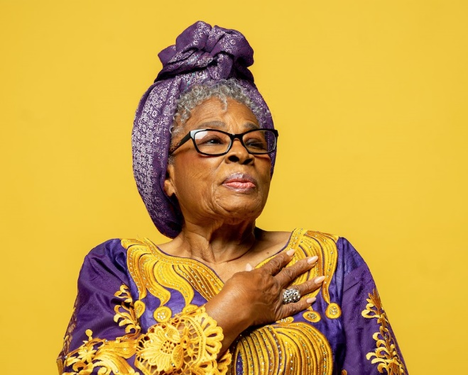

***Created for distribution by the African American History Committee of the Chesterfield Historical Society of VA.***

***Please learn more about us. We welcome your membership. See CHSV/AAHC Facebook and Websites for more details***